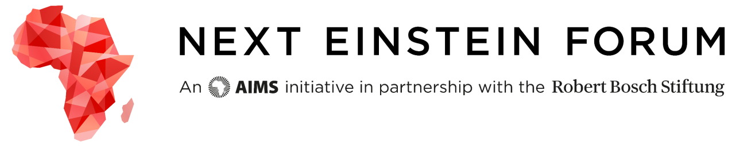
NEF Ambassadors Application
Please ensure you have read the eligibility requirements and criteria for selection. For more information: nef.org/ambassadors. All applications are to be submitted by email to NEFAmbassadors@nef.org in English or French.
Please attach your CV to the end of the application form. The final document should include this application form and CV in ONE file. Applications that do not follow this format and naming convention will not be accepted. The file should be in PDF format and it should be labeled CountryofCitizenship - Lastname, Firstname Middlename. For example, Jane Lyon Doe from Mauritius would label her final PDF file as Mauritius – Doe, Jane Lyon.
Deadline: 31 August 2015 at 23:59 Pacific Standard Time
- Please provide your contact information (all fields mandatory):

First name:
Last name:
Date of birth (YYYY/MM/DD):
Nationality:
Mailing address:
City:
State/Province/County (N/A if not applicable):
Postal Code (N/A if not applicable):
Country:
Phone number:
Email:
- We want to get to know you better and to do this we would love to hear you speak to us by video. The video does not have to be professionally done (it can be taken with a camera or phone, for example), but the picture and sound should be clear. In the video, please clearly:
- Tell us why you want to be a NEF Ambassador?
- What special skills and contributions would you bring to your role as NEF Ambassador?

You can send the video via Google, We Transfer or Dropbox or via Google -please paste the link here (setting must be on public):
Please enter your link here.
- Answer the following questions in no more than 250 words each in the space provided:
  - What do I want to learn from and share at the NEF Global Gathering?
Please enter your response here. Maximum of 250 words

  - What are at least three strategies I will use to share this knowledge with at at least 20k people when I return to my community?
Please enter your response here. Maximum of 250 words
4. Please provide one to two online links that demonstrate an active presence online. Describe the link(s) and its significance. How many followers did you have and what strategies did you use to engage your followers? (max 150 words – links can include Facebook, YouTube, Twitter, blog, Instagram, and other mainstream social media outlets).
First Link
Please enter your response here. Maximum of 150 words

Second Link
Please enter your response here. Maximum of 150 words
By submitting this application, I agree that my name, photo, video and other information may be user on the NEF promotional materials and social media platforms and grant permission to AIMS and the Next Einstein Forum to use them.

Initial here:

I hereby certify that the information submitted on this form and in the attached documents is true and accurate to the best of my knowledge.

Signature:

Please note that if you do not have an electronic signature, you can print, sign and scan application form.

Date:

PLEASE INSERT YOUR CV HERE and check that you have labelled this file correctly before submitting your application.

